Experiment 10
Packet-Switched vs Circuit-Switched Networks

Lab 10 Objectives:
● Compare packet-switched and circuit-switched networks for data transfer efficiency.
Prerequisites: The prerequisites of this lab are-
● Basic understanding of networking concepts and switching techniques.
● Familiarity with data transfer methods and network performance metrics.

Outcomes: By the end of this lab, students will be able to:

● Understand the differences between packet-switched and circuit-switched networks.
● Analyze data transfer efficiency, delay, and reliability in both approaches.
● Compare bandwidth utilization and resource allocation.

Experiment Description
- Simulate Packet-Switched Network:
Use network simulation software like Cisco Packet Tracer or NS2/NS3 to simulate a packet-switched network where data is broken into packets and routed independently.
- Data Transfer and Measurement in Packet-Switched Network:
Transfer data between two nodes. Measure delay (time for data to travel from source to destination) and throughput (amount of data transferred per unit time) using tools like ping, iperf.
- Simulate Circuit-Switched Network:
Simulate a circuit-switched network where a dedicated communication path is established before data transfer begins.
- Data Transfer and Performance in Circuit-Switched Network:
Transfer data over the circuit-switched network and analyze metrics like delay, throughput, and bandwidth utilization.
- Compare Both Networks:
  - Compare bandwidth utilization: Packet-switched networks share bandwidth dynamically, while circuit-switched networks allocate fixed bandwidth.
  - Analyze latency and reliability in both.
  - Observe how network congestion and failures affect the performance of both types.
- Document Results:
Collect performance data, tabulate results, and note key observations.
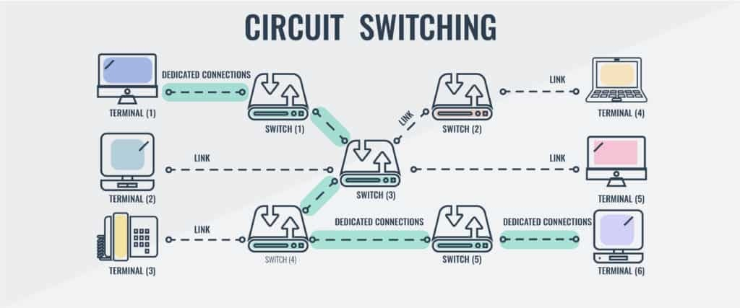

Tools Used
- Network Simulation Software: Cisco Packet Tracer, NS2/NS3
- Command-Line Utilities: ping, traceroute, iperf

Performance Comparison Table
Parameter | Packet-Switched Network | Circuit-Switched Network
Data Transfer Method | Data sent in small packets independently routed | Dedicated path established before data transfer
Bandwidth Utilization | Dynamic, shared among users | Fixed bandwidth reserved per connection
Delay (Latency) | Variable; depends on network congestion | Generally low and constant during the connection
Throughput | Can vary based on network load | Consistent, reserved bandwidth
Resource Allocation | Allocated on demand per packet | Allocated exclusively for the session duration
Reliability | Depends on routing, can be affected by packet loss | High, due to reserved path and no sharing
Congestion Impact | Higher impact, packets can be delayed or dropped | Less impacted, dedicated circuit ensures quality
Failure Handling | Packets rerouted via alternative paths | Connection lost if circuit breaks, needs re-establishment

Observations
- Packet-Switched Networks:
  - Efficient bandwidth usage since the network resources are shared dynamically.
  - Higher delay variability due to congestion and packet queuing.
  - More scalable and flexible for bursty traffic.
  - Better suited for data traffic like internet browsing, email, etc.
  - Packet loss may occur, but protocols like TCP handle retransmissions.

- Circuit-Switched Networks:
  - Guarantees consistent bandwidth and delay once circuit is established.
  - Inefficient bandwidth usage for idle periods within a connection.
  - Less flexible, setup time required to establish connection.
  - Ideal for real-time services requiring constant data rate (e.g., traditional voice calls).
  - Connection fails completely if circuit breaks, needing re-establishment.

- Impact of Congestion and Failures:
Packet-switched networks handle congestion by buffering and rerouting packets, which can increase delay but maintains communication. Circuit-switched networks either block new calls during congestion or drop active calls if failure occurs.

Analysis Report
Packet-switched networks provide efficient utilization of bandwidth by allowing multiple data streams to share the same network resources. This dynamic resource allocation supports a larger number of users but introduces variability in delay and potential packet loss. Reliability is maintained through error correction and retransmission protocols.
Circuit-switched networks guarantee dedicated bandwidth and low, constant latency during the connection period, making them suitable for voice and video calls requiring steady data flow. However, the fixed allocation results in inefficient bandwidth usage, especially when the channel remains idle. Additionally, circuit establishment introduces call setup delays.
In environments with heavy network congestion, packet switching offers better resilience by rerouting packets, whereas circuit switching may result in call blocking or drops.

